Determinants of Alzheimer

After removing the missing values and rows with Group = “Converted”, we proceed with the analysis.

Analyse using descriptive statistics (both graphical and numerical representations) on the dataset project data.csv. Generate an appropriate table as summary and appropriate graphs (e.g., boxplots, histograms and scatterplots).

Summary Statistics of the Entire Sample

Variables | N | Mean | Standard deviation | Median | Trimmed Mean | Mean absolute deviation | Min | Max | Range | Skew | Kurtosis
M/F | 317 | 0.43 | 0.5 | 0 | 0.42 | 0 | 0 | 1 | 1 | 0.27 | -1.93
Age | 317 | 76.72 | 7.81 | 76 | 76.55 | 8.9 | 60 | 98 | 38 | 0.19 | -0.43
EDUC | 317 | 14.62 | 2.93 | 15 | 14.64 | 4.45 | 6 | 23 | 17 | -0.09 | 0.04
SES | 317 | 2.55 | 1.12 | 2 | 2.53 | 1.48 | 1 | 5 | 4 | 0.15 | -1.08
MMSE | 317 | 27.26 | 3.86 | 29 | 28.07 | 1.48 | 4 | 30 | 26 | -2.29 | 6.75
CDR | 317 | 0.27 | 0.38 | 0 | 0.21 | 0 | 0 | 2 | 2 | 1.48 | 2.59
eTIV | 317 | 1493.58 | 179.72 | 1476 | 1483.77 | 176.43 | 1106 | 2004 | 898 | 0.51 | -0.18
nWBV | 317 | 0.73 | 0.04 | 0.73 | 0.73 | 0.04 | 0.64 | 0.84 | 0.19 | 0.18 | -0.5
ASF | 317 | 1.19 | 0.14 | 1.19 | 1.19 | 0.15 | 0.88 | 1.59 | 0.71 | 0.07 | -0.26

Summary Statistics of the Alzheimer (Demented)

Variables | N | Mean | Standard deviation | Median | Trimmed Mean | Mean absolute deviation | Min | Max | Range | Skew | Kurtosis
M/F | 127 | 0.6 | 0.49 | 1 | 0.62 | 0 | 0 | 1 | 1 | -0.4 | -1.86
Age | 127 | 76.2 | 7.35 | 76 | 75.95 | 8.9 | 61 | 98 | 37 | 0.35 | -0.26
EDUC | 127 | 13.83 | 3.03 | 14 | 13.9 | 2.97 | 6 | 20 | 14 | -0.19 | 0.06
SES | 127 | 2.77 | 1.2 | 3 | 2.79 | 1.48 | 1 | 5 | 4 | -0.14 | -1.18
MMSE | 127 | 24.32 | 4.66 | 26 | 24.83 | 4.45 | 4 | 30 | 26 | -1.3 | 2.58
CDR | 127 | 0.67 | 0.3 | 0.5 | 0.63 | 0 | 0.5 | 2 | 1.5 | 2.16 | 5.94
eTIV | 127 | 1490.7 | 172.38 | 1477 | 1480.35 | 127.5 | 1143 | 1957 | 814 | 0.6 | 0.16
nWBV | 127 | 0.72 | 0.03 | 0.71 | 0.71 | 0.03 | 0.65 | 0.81 | 0.16 | 0.37 | -0.47
ASF | 127 | 1.19 | 0.13 | 1.19 | 1.19 | 0.11 | 0.9 | 1.53 | 0.64 | 0.03 | -0.1

Summary Statistics of the Non-Demented

Variables | N | Mean | Standard deviation | Median | Trimmed Mean | Mean absolute deviation | Min | Max | Range | Skew | Kurtosis
M/F | 190 | 0.32 | 0.47 | 0 | 0.28 | 0 | 0 | 1 | 1 | 0.76 | -1.43
Age | 190 | 77.06 | 8.1 | 77 | 76.99 | 8.9 | 60 | 97 | 37 | 0.09 | -0.53
EDUC | 190 | 15.14 | 2.74 | 16 | 15.12 | 2.97 | 8 | 23 | 15 | 0.12 | -0.37
SES | 190 | 2.39 | 1.05 | 2 | 2.36 | 1.48 | 1 | 5 | 4 | 0.32 | -0.9
MMSE | 190 | 29.23 | 0.88 | 29 | 29.36 | 1.48 | 26 | 30 | 4 | -1.05 | 0.6
CDR | 190 | 0.01 | 0.05 | 0 | 0 | 0 | 0 | 0.5 | 0.5 | 9.52 | 89.03
eTIV | 190 | 1495.5 | 184.89 | 1474.5 | 1486.87 | 185.32 | 1106 | 2004 | 898 | 0.45 | -0.39
nWBV | 190 | 0.74 | 0.04 | 0.74 | 0.74 | 0.04 | 0.64 | 0.84 | 0.19 | -0.01 | -0.39
ASF | 190 | 1.19 | 0.14 | 1.19 | 1.19 | 0.16 | 0.88 | 1.59 | 0.71 | 0.1 | -0.39

Here we look at the relationship between independent variables and dependent variable

- Gender and Alzheimer (Demented) or not (Non-demented)

From the above graph in the given sample, males have high count of Alzheimer as compared to females. The proportion of males and females who have Alzheimer are 55% and 28% in the given sample. Females have a higher representation than males in the sample (Females are 180 and Males are 137). Total sample size is 317.

- Age and Alzheimer (Demented) or not (Non-demented)

The persons who have Alzheimer have an average age of 76.20 years while the persons who do not have Alzheimer have an average age is 77.06 years.

- Education and Alzheimer (Demented) or not (Non-demented)

The educated persons who have Alzheimer have an average years of education of about 13.83 years while the educated persons who do not have Alzheimer have an average years of education of nearly 15.14 years.

- Socioeconomic Status and Alzheimer (Demented) or not (Non-demented)

The lower socio economic status (=2) has the highest representation in the sample. The least representation in the sample is by the highest socio economic status (=5).

The highest proportion of Alzheimer is present in the highest socio economic status (=5). The least proportion of Alzheimer is present in lower socio economic status (=2)

- Mini Mental State Examination and Alzheimer (Demented) or not (Non-demented)

The mini mental state examination is highly skewed for Non demented people as compared with demented people. The mean of mini mental state examination of demented people is 24.32 while the average of mini mental state examination of nondemented people is 29.23.

- Clinical dementia rating (CDR) and Alzheimer (Demented) or not (Non-demented)

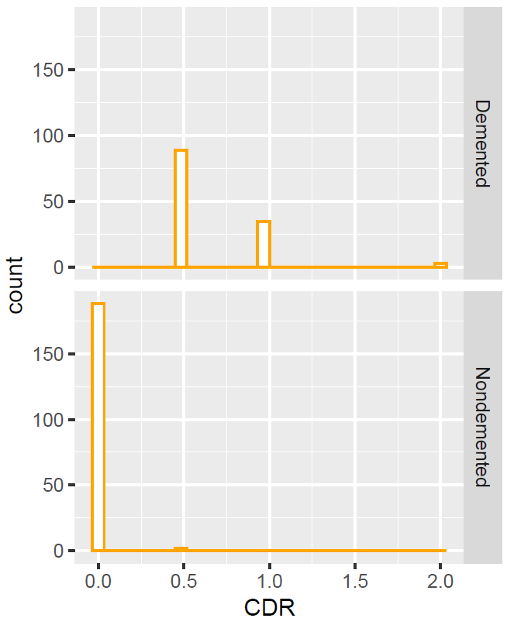

For nondmeneted people, CDR is 0 while for demented people CDR is 0.5 or 1.

- Estimated total intracranial volume and Alzheimer (Demented) or not (Non-demented)

Estimated total intracranial volume is almost the same for demented and nondemented people.

- Normalize whole brain volume and and Alzheimer (Demented) or not (Non-demented)

The mean for normalized whole brain volume for nondemented people (0.72) is higher than for demented people (0.74).

- Atlas scaling factor and and Alzheimer (Demented) or not (Non-demented)

Atlas scaling factor seems to be the same for Demented and Non demented people.

Correlation plots of all the Independent Variables. ASF and CDR are found to be highly correlated with other variables.

Implement clustering algorithms, demonstrate the results and comment on that.

For implement clustering algorithm we fit the normalize the data. We normalize the data by subtracting the mean and dividing by standard deviation. After normalizing the data, we calculate the Euclidean distance.

Hierarchical agglomerative clustering using Complete linkage:

Here we divide our Dendograme into two clusters. Dendogram is a bottom up approach. We also tried using Average linkage but the dendrogram seems to be not proper. It is illustrated below.

Using cutree command in R for complete linkage, we get 143 observations in cluster 1 and 174 observations in cluster 2.

Characterizing the clusters shows that cluster 1 is associated with higher chance of being male (on average), higher average age, higher average education, lower average social economic status, lower average mini mental state examination, higher average clinical dementia rating, higher average estimated total intracranial volume, lower average normalizes whole brain volume and lower average atlas scaling factor. Cluster 2 is associated with more chance of being female (on average), lower average education, lower average age, higher average social economic status, higher average mini mental state examination, lower average clinical dementia rating, lower average estimated total intracranial volume, higher average normalize whole brain volume and higher average atlas scaling factor.

Further we use the scree plot.

The highest drop in the within sum of squares comes at 2 and 3.

Non-Hierarchical K mean clustering:

K mean clustering with 2 clusters contain 90 and 227 observations in each cluster.

The within cluster sum of squares is 1022.24 and 1331.29. Ideally, the within cluster sum of squares should be as small as possible. The ratio between_SS cluster / total_SS cluster is 17.2%. Ideally, this number should be as large as possible.

Cluster 1 is associated with higher chance of being male (on average), higher average of age, lower average education, higher average socio economic status, lower average mental state examination, higher average clinical dementia rating, lower average total intracranial volume, lower average normalize whole brain volume, higher average atlas scaling factor.

Cluster 2 is associated with lower chance of being female (on average), lower average of age, higher average education, lower average socio economic status, higher average mental state examination, lower average clinical dementia rating, higher average total intracranial volume, higher average normalize whole brain volume, lower average atlas scaling factor.

K mean clustering with 3 clusters contain 161,67 and 89 observations in each cluster.

The within cluster sum of squares is 807.1084 506.5956 and 484.9509. Ideally, the within cluster sum of squares should be as small as possible. These numbers are much smaller as compared with cluster 2. The ratio between_SS cluster / total_SS cluster is 36.8%. This is higher than cluster 2.

Further as we go up more clusters the within sum of square will reduce and the ratio between_SS cluster / total_SS cluster will increase (With cluster 4 it is 43.6%)The gain is not that high when we go from Cluster 2 to cluster 3 (It is 19%) as compared to cluster 3 to cluster 4 (It is 8%).

We should go for cluster 2 or cluster 3 using k mean clustering.

Fit a logistic regression model using the remaining variables to predict variable Group. Describe the produced model and comment on what it demonstrates.

We take log of several variables to scale down the values. Further we divide the data into training and testing data set (80% training data and 20% testing data).

After several permutations and combinations, we construct the following model,

Group ~ Age + Year of education + Mini mental state examination + Normalize whole brain volume + Socio Economic Status + error

 | Estimate | Std. Error | z value | Pr(>|z|)
(Intercept) | 206.17 | 32.55 | 6.33 | 0.00***
Age | -13.06 | 3.03 | -4.32 | 0.00***
EDUC | -3.20 | 1.62 | -1.97 | 0.05*
MMSE | -35.78 | 5.77 | -6.20 | 0.00***
nWBV | -29.64 | 7.53 | -3.94 | 0.00***
SES2 | -1.18 | 0.63 | -1.88 | 0.06.
SES3 | 0.08 | 0.68 | 0.12 | 0.91
SES4 | -0.59 | 0.78 | -0.75 | 0.45
SES5 | -5.82 | 4.86 | -1.20 | 0.23

Age, EDUC, MMSE and nWBV are negative. This show that an increase in any of these variables, the log of odds of getting dementia goes down (A person likely to be nondemented). These results confirm with the graphs and summary statistics. Lower Socio Economic status is significant as compared to higher socio economic status.

Misclassification error in Training Data using Confusion Matrix.

 | Actual
Predicted | 0 | 1
0 | 146 | 27
1 | 10 | 78

The misclassification error in Training data set is 14.17%. The train data set correctly classifies 85.82%.

Misclassification error in Test Data using Confusion Matrix

 | Actual
Predicted | 0 | 1
0 | 31 | 5
1 | 3 | 17

The misclassification error in Training data set is 14.28%. The test data set correctly classifies 85.71%.

Implement a feature selection method to find the most important features, demonstrate your
results and discuss on your findings.

We use a forward stepwise section method to find the most important features.

First, we fit the intercept-only model. This model had an AIC of -450.23.

Next, we fit every possible one-predictor model. The model that produced the lowest AIC and also had a statistically significant reduction in AIC compared to the intercept-only model used the predictor CDR. This model had an AIC of -870.39.

Next, we fit every possible two-predictor model. The model that produced the lowest AIC and also had a statistically significant reduction in AIC compared to the single-predictor model added the predictor EDU. This model had an AIC of -881.7.

Next, we fit every possible three-predictor model. The model that produced the lowest AIC and also had a statistically significant reduction in AIC compared to the two-predictor model added the predictor M/F. This model had an AIC of -892.96.

Next, we fit every possible four-predictor model. It turned out that none of these models produced a significant reduction in AIC, thus we stopped the procedure.

The final model turns out to be:

Group ~ 4.19 + (1.05*CDR) - (0.48*EDU) + (0.17*M/F) – (0.50*eTIV )

We use a backward stepwise section method to find the most important features.

Here is how to interpret the results:

First, we fit a model using all predictor variables and calculate the AIC of the model.

Next, we removed the variable (SES) that lead to the greatest reduction in AIC and also had a statistically significant reduction in AIC compared to the full predictor variable model.

Next, we removed the variable (eTIV) that lead to the greatest reduction in AIC and also had a statistically significant reduction in AIC compared to the previous predictor variable model.

We repeated this process until removing any variable no longer led to a statistically significant reduction in AIC.

The final model turns out to be:

Group ~ 1.54 + (0.16)*M/F - (0.30*Age) +(1.06*CDR) - (0.20*EDU) – (0.16*MMSE ) – (0.99*nWBV) + (0.44*ASF)

